ALL INDIA INSTITUTE OF SPEECH AND HEARING
अखिल भारतीय वाक एवं श्रवण संस्थान
DEPARTMENT OF SPECIAL EDUCATION
विशेष शिक्षा विभाग
MARCH MONTHLY REPORT 2017
- ACADEMIC ACTIVITIES
- Short-term Training Programs: NIL
- Faculty report
- Dr. M. Pushpavathi – HOD in Special Education
    - Supervised the work related to graduation day and preparation of summer camp
    - Member of an enquiry committee and attended the meeting related to the enquiry on 22

- Dr. G. Malar, Reader in Special Education

- Co-compiler for M.S.Ed.(HI) Dissertation Based Articles 2015-16
- CBCS Coordinator for B.Ed.Spl.Ed. (HI)
- Mentor for B.Ed.Spl.Ed. (HI)
- Depute staff to Department for Tele-rehabilitation for Persons with Communication Disorders
  - Preparation of adapted lessons for clients & academic screening tools (Maths & EVS – grades I to VIII)
- Member of Expert Committee of Product Development Cell
- Member-Secretary of Learning Disabilities Clinic
  - Postings in Wednesday afternoons. Assistance to Chairperson in preparing minutes of meetings. Carried out educational screening/assessment of 6 learners during the month.
- I/C of SEA-U, Department of Special Education
- I/C of Research & Data Base Unit, Department of Special Education
- I/C of EduTechLab, Department of Special Education
- Member-Secretary of Team for Delivering Services for School-Aged Children [including CSS, IEP, NFE & Mainstream School Adoption], Department of Special Education
- Supervisor for 10 preschool groups – Aambal II, Sebu, Maavu, Baale, Sampige I & II, Sugandharaja I & II, Mallige II, and Sevanthi I

Name of the Faculty |  | Dr. Alok Kumar | Dr. G. Malar | Dr. Prithi Venkatesh | Dr. P. Vijetha
Clinics
No. of cases evaluated at SEA-U |  | 16 | Screening: 24  Assessment: 1 | 10 | 06
No. of cases supervised individually |  | 32 | 34 children in 6 groups thru’ 7 sessions of classroom observations | NIL | NIL
No. of groups supervised |  | 09 | 10 | 8 | 15
No. of meeting with parents |  | 08 | 08 | 7 | 08
Educational Guidance |  | 01 | Clients: 11  Sessions:11 | NIL | 01 (1 session)
Academic
Classes taken
B.Ed.  Spl.Edn(HI) | Theory | 17 classes | 29 Sessions | 15 classes | 24 classes
B.Ed.  Spl.Edn(HI) | Practical | 8 hours | 10 hours | 16 hours Coordinating preschool practical postings of B.Ed.Spl.Edn (HI) trainees from 30th March 2017 till 27th April 2017. | 20 hours
DECSE(HI) | Theory |  |  | 18 classes | 14 classes
DECSE(HI) | Practical |  |  | Coordinated practical postings till 25th March 2017. | 52 hours
Any other |  |  |  |  | - *From 1st to 31st March 2017, coordinated B.Ed. II year teacher assistant postings in Inclusive school “I can school”, Mysore  - Coordinated the practice teaching sessions of DECSE (HI) trainees in Preschool and paper II practicum.  - Correction of B.Ed II year observation reports in “I can school”, Mysore  - Coordinated the work of E-affiliation – UOM of dept. faculty and staff.  On 30th March 2017, oriented three special educators and three B.Ed II student trainees on school readiness test to be carried out for outgoing children.
Research
Paper published |  | NIL |  | Chapter in Book ICT in Education ‘Information (ISBN Number-978-93-85957-08-6) and Communication Technology for Children with Communication disorders’ | NIL
Paper in press/ in progress |  | 03 |  | Proposed a chapter titled ‘Sibling Rivalry Issues in Families of Children with Communication Disorders’ for IGI Global Publisher | NIL
Paper presentation |  | As served as a Resource person in National Workshop and topic was “Communication options:Oralism & Total Communication “on 23/03/17 and 24/03/17 at Guru Ghasidas central University,Bilaspur, Chattisgarh |  |  | Prepared and Presented paper titled “Impact of Adapted social studies lessons on learning in children with hearing impairment” in the National Seminar on Research in Social Sciences Education in Indian schools organized by DESS, NCERT held from 15th to 17th March 2017 at New Delhi. On 21st March 2017, submitted the report
ARF Project |  |  | Sanctioned 1
Thesis Evaluation/Project Review |  | Reviewed J.I.S.H.A articles
Any other
Meeting held |  |  | - 2 monthly meetings with I & II B.Ed. students  - 1 meeting with SEA-U members  - 2 meetings regarding ARF project  - 1 meeting with class teachers of out-going preschool children regarding conduction educational assessment |  | - On 3rd March 2017,  attended meeting with HOD for regarding Educational Assessment  - On 7th March 2017,  Attended Faculty meeting to discuss Educational Assessment.
Meeting attended |  | BOE meeting at board room 28/03/17 | 1 with HOD – Special Education | BOE Meeting attended on 28th March 2017.
AV preparation |  |  | 2 PPTs for I B.Ed.Spl.Ed. (HI
Brochures |  |  |  | Prepared Draft pamphlet with course details for publicity of courses.
Orientation Programme
Workshop |  |  |  |  | On 23rd and 24th March 2017, participated in ISO 9001:2015 Internal Auditors training program presented by Mr. Rajesh.
Roles & Responsibilities
Co-ordination |  | Infant & Toddler Unit | - CBCS Coordinator for I & II B.Ed. Spl.Ed. (HI)  - Mentor for I & II B.Ed.Spl.Ed. (HI)  - Compilation of M.S.Ed. Student Dissertation-based Articles 2014-15  - Intra-Department  - SEA-U  - EduTechLab  Research & Database Unit |  | ISO  - On 7th March 2017, Met HOD to discuss about ISO for process manual changes.  - On 10th March 2017, submitted process manual changes to ISO implementation Cell.  Service for School aged children  - On 2nd March 2017, meeting with members was conducted discussing about the process of services.  - Prepared an abstract to be presented in a seminar conducted by Amity university, New Delhi.
Member secretary |  | Preschool | - LD Clinic (in DCS)  - Services for School-Aged Children (in Department of Special Education) | Served as member secretary in catering committee for Open Day Celebration on 3rd February 2017. In this connection attended two rounds of meeting with chairperson at director’s Chamber  Serving as a member Secretary in SEAU | Service for Infant and Toddlers
Member in |  | SEA-U | - TCPD  - Product Development Cell  - Evaluator for UoM UG courses in special educator  - Preschool Supervision | SEA-U | SEA –U  Prepared school readiness reports of four clients and submitted
Mentor |  | M.Sc. -1st Year -Audiology
- Orientation Programs:

Name/Topic of the Program | Coordinator | Objectives | Targeted Audience | Number of Participants | Date
Orientation on Preschool Training for Children with Communication Disorders | Dr. G. Malar | Developing awareness on preschools education for Children With Special Needs | II M.Sc. (SLP) students | 12 | 03.03.2017
Orientation on Preschool Training for Children with Communication Disorders | Dr. Prithi Venkatesh | Developing awareness on preschools education for Children With Special Needs | Maharani college, Mysuru | 7 students | 15.03.2017
Orientation on Preschool Training for Children with Communication Disorders | Mr. Gururaj D | Developing awareness on preschools education for Children With Special Needs | University of Mysore, Mysuru | 5 students | 17.03.2017
Orientation on Preschool Training for Children with Communication Disorders | Mr. Raj Kumar | Developing awareness on preschools education for Children With Special Needs | Dr. Robert (UK)  chiropractioner | 02 | 28.03.2017
Orientation on Preschool Training for Children with Communication Disorders | Dr. Prithi Venkatesh | Developing awareness on preschools education for Children With Special Needs | St. Philomena's college, Mysuru | 02 MSW students | 31.03.2017

- Seminars/Conferences/Workshops: NIL
- In- house training Programs: NIL
- Staff Enrichment Programs (SEP’s) : NIL
- Empowering Educators in Education (E³): NIL
- Guest Lectures :
- Invited Talks:
- Development of Materials to Support Learning
- Service in Academic bodies of other Organizations- NIL
- Membership in Professional Organizations/Associations - NIL
- Participation in Committees/Taskforce and Panels setup by other organizations/agencies-
- Any Other (Please Specify).

        - Parents Help Parents Program (PHPP): This program aims to provide moral support and boost the confidence, motivation of the parents of CWSN. In there, parents of successfully rehabilitated child with special needs will be sharing their experience and interacting with parents.

SL No. | Date | Resource person | Beneficiaries
1 | 28.03.2017 | Mrs. Anusudha parent of Nishanth a child with intellectual deficit. | 117 Parents of Children with special needs. | 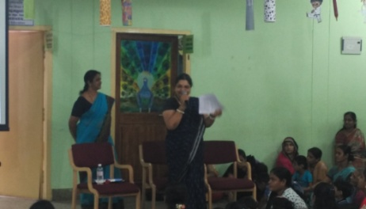

- RESEARCH ACTIVITIES
- Research Projects
- Completed Research Projects: NIL
- New Research Projects: 02

- Title of ARF - Development and Evaluation of Indigenous curriculum oriented computer based tutor for concept learning in preschool children with special needs.
- Principal Investigator – Ms. P.V.Ramanakumari
- Co-Investigators – Dr. Ajish K Abraham and Ms. P.V.Manjula
- Research Assistant – Mr. Anil Abbur R.
- Date of Starting – 18th January 2017
- Progress –Story board writing of Animals and birds and My journey. On 30th March 2017 checked the characters of My family (primary level) developed by the animators.
- ARF Project No. 65
- Title: Effect of Resource Materials on Impact of Inclusive Education in Children with Intellectual Disabilities (ID) and Learning Disabilities (LD)
- Duration: 12 months from January 2017
- Budget: Rs. 3,85,000/-
- Progress: Withdrawal of first research assistant due to health issues, and replacement in the final week of March 2017. Investigators are carrying on with preparation of training materials.

- On-going Research Project : 0
- Doctoral and Post-Doctoral Programs: NIL
- Degree Awarded:
- Thesis awarded:
- Thesis Submitted:
- Under Progress:
- Research Papers presented at National/International Conferences/Seminars:
- Research Papers Published(in APA format):
    - Papers published in Conference/Seminar Proceedings
    - Research Papers in press- NIL
    - Research Papers published in Journals:
    - No. of in-house journal articles:
    - Books published.

- Book chapters published(in APA format): 15
- Janvar a book about animals in Hindi prepared by Mr. Murshidul Alam
- Prakruthi aur rutuyan a book about nature and season in Hindi prepared by Dr. Prithi Venkatesh.
- Bachoun ke liye kathaen aur kavitayen - 1 a book of story and rhyme in Hindi prepared by Ms. Manjula P. V.
- Bachoun ke liye kathaen aur kavitayen – 2 a book of story and rhyme in Hindi prepared by Dr. Kadambari N. and Mr. Murshidul Alam
- Bachoun ke liye kathaen aur kavitayen – 3 a book of story and rhyme in Hindi prepared by Mr. Harish Kumar, Dr. Kadambari N. and Mr. Murshidul Alam
- Common Objects in Hindi by Dr. Kadambari N
- Namma mane a book about Our House in Kannada prepared by Ms. Sumana H. P.
- Keetagalu a book about Insects in Kannada prepared by Mr. Subramanya K. R.
- Pranigalu a book about animals in Kannada prepared by Ms. Vijayalakshmi S.
- Vahanagalu a book about Vehciles in Kannada prepared by Ms. Leena C. C.
- Olleya Abhyasagalu a book about Good Habits in Kannada prepared by Ms. Shobha B. N.
- Vruttipararu a book about Professionals in Kannada prepared by Ms. Leelarani S. B.
- Hannugalu a book about fruits in Kannada prepared by Ms. Latha .C
- Telugu Kathalu a book of stories in Telugu by Mr. R. Rajkumar
- Telugu Geyalu a book od rhymes in Telugu by Mr. R. Rajkumar

- Books in press :
- Books/Manuals/Seminar Proceedings edited
- Journal Editorship
- Scholarly Reviewing Activities
- Reviewer for Scholarly Journals
- M.S.Ed (HI) Dissertations Guided by Faculty
- Clinical Support Services to Patients and Family
- Details of Certificates Issued:

Details of Bonafide Certificates Issued:

Sl.No. | Nature of Special Needs in Clients | No. of Certificates Issued | Purpose
1 | DSL,MR | 02 | For applying driving licence,/father deputation.
2 | DSL,HL | 03 | For applying scholarship
- Clinical Electronic Services: NIL
V) CENTRAL FACILITIES
      - Library and Information Services
      - Public Information Activities
- Major Events of the month of December with a brief account:

- Name of the Programme/ Event: Celebration of Ugadi, Holi & Saraswathi Pooja in
Preschool
Date: 24.03.2017
Coordinated by: - Ms. Latha .C & Ms. Dhivya
Brief note: For creating awareness among children about the festivals celebrated in India, Ugadi and Holi Festivals were celebrated at the department. Saraswati Pooja was also performed. The importance of the festivals and having Bevu Bella was explained to the children. Sweets and khara were distributed to the children.

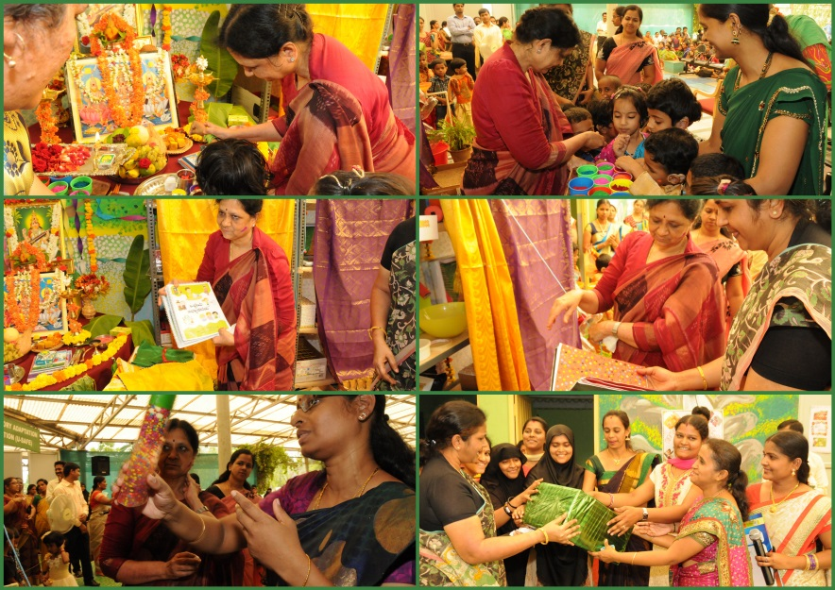

- Press Releases and Media Coverage
- Institute Publications -
- Material Development
Sl.  No. | Nature of Teaching-Learning Materials | Skill | Number
1. | Flash cards | For all skill areas | 170 sets
2. | Work Cards | For all skill areas | 115 sets
3. | Charts | For all skill areas | 30
4. | PPT | For all skill areas | 20
5. | Models | For all skill areas | 1
6. | Sentence strips | For all skill areas | 110 sets
7. | Others | For all skill areas | 0
- AWARDS AND HONORS RECEIVED BY FACULTY AND STAFF
- EXTRA CURRICULAR ACTIVITIES
- Others:
IX. EMINENT VISITORS: NIL
X. ANY OTHER
- Official Language Implementation:
- One word a day in Hindi.

- SPECIAL EDUCATIONAL SERVICES
- Pre-School Training and Special Education
  - Monthly Statistics Special Educational Services

S. No. | Nature of Services (I/C)
- Special Educational Assessment Services (Dr. G. Malar)
 |  | Nature of Special Need  Language |  | ASD / PDD NOS | Hearing Loss | Intellectual Disability |  | Learning Disability | Motor Problems |  | Multiple Disabilities | Others | No. of Clients | No. of Sessions | Total No. of Sessions
1. | Screening & Referral | Kannada |  | 04 | 11 | 09 |  | - | - |  | 04 | 02 | 30 | 30 | 58
1. | Screening & Referral | Malayalam |  | 02 | 06 | 03 |  | - | - |  | 03 | 03 | 17 | 17 | 58
1. | Screening & Referral | Hindi |  | - | 04 | 01 |  | 01 | - |  | 01 | - | 07 | 07 | 58
1. | Screening & Referral | Urdu |  | - | 01 | - |  | - | - |  | - | - | 01 | 01 | 58
1. | Screening & Referral | English |  | - | - | - |  | - | - |  | - | - | - | - | 58
1. | Screening & Referral | Telugu |  | - | - | 01 |  | - | - |  | - | 01 | 02 | 02 | 58
1. | Screening & Referral | Tamil |  | - | - | - |  | - | - |  | - | - | - | - | 58
1. | Screening & Referral | Any Other |  | - | - | - |  | - | 01  (Marathi) |  | - | - | 01 | 01 | 58
1. | Screening & Referral | Total No. of Clients |  | 06 | 22 | 14 |  | 01 | 01 |  | 08 | 06 | 58 | 58 | 58
2. | Assessment & Report | Kannada |  | - | 01 | - |  | - | - |  | - | - | 01 | 06 | 03
2. | Assessment & Report | Malayalam |  | - | 01 | - |  | - | - |  | - | - | 01 | 02 | 03
2. | Assessment & Report | Hindi |  | - | - | - |  | - | - |  | - | - | - | - | 03
2. | Assessment & Report | Urdu |  | - | - | - |  | - | - |  | - | - | - | - | 03
2. | Assessment & Report | English |  | - | - | 01 |  | - | - |  | - | - | 01 | 04 | 03
2. | Assessment & Report | Telugu |  | - | - | - |  | - | - |  | - | - | - | - | 03
2. | Assessment & Report | Tamil |  | - | - | - |  | - | - |  | - | - | - | - | 03
2. | Assessment & Report | Any Other |  | - | - | - |  | - | - |  | - | - | - | - | 03
2. | Assessment & Report | Total No. of Clients |  | - | 02 | 01 |  | - | - |  | - | - | 03 | 12 | 03
2. | Places from which seen: (1)Karnataka: 42 (2)Kerala: 15 (3)AP: Nil (4)TN: 1 (5)Other Parts of India: Nil (6)Any other: Nil
2. | Age groups seen:(1)Birth to 2.5yrs: 12 (2)2.5⁺ to 6 yrs: 30 (3)6yrs⁺ to 16 years: 12 (4)16yrs⁺: 2
2. | Total No. of Referrals: (1)Educational Assessment: 4 (2)Educational Guidance: 1 (3)PIP: 9 (4)PPEP/ PBC/ GECS: 36 (5)CSS/IEP/NFE/DET: 4 (6) Any Other Services at AIISH: 2 (7) Any Other Services Outside AIISH: 2
2. | No. of Reports Issued: (1) Early Development Skills: Nil (2) School Readiness: 01(3) Curriculum-Based Assessment: 01 (4) Post-School Preparedness: Nil
3. | On-going Assessment (as part of service delivery) |  | Figure: 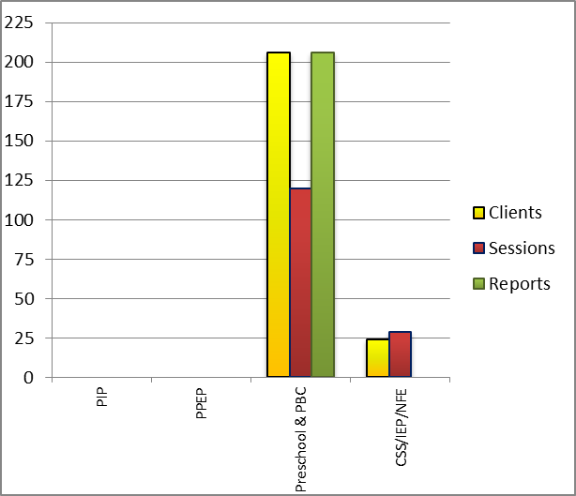
 | Details of Assessments |  | No. of Children |  |  |  | No. of Assessment Sessions |  |  | No. of Reports
 | As part of Parent-Infant Programme: |  | Nil |  |  |  | Nil |  |  | Nil
 | As part of Preschool Parent-Empowerment Programme: |  | Nil |  |  |  | Nil |  |  | Nil
 | As part of Preschool Training Programme &  As part of Preschool Bridge Course Programme: |  | 206 |  |  |  | 120 |  |  | 206
 | As part of CSS/ IEP/NFE: |  | 15 |  |  |  | 17 |  |  | Nil

Preschool Training (Ms. Prithi Venkatesh):Preparatory programme for schooling providing training in self-help, cognitive, language and (pre) academic skills, Preschool Bridge course
Language & Disability | No. of Groups | No. of Children
 |  | MALE | FEMALE
Kannada ASD & ID &MD | 14 | 44 | 18
Kannada HI | 10 | 41 | 28
Malayalam HI | 1 | 3 | 2
Malayalam ASD & ID & MD | 10 | 23 | 15
Hindi HL | 1 | 7 | 0
Hindi MD & ID & ASD | 2 | 6 | 2
English ID, ASD | 2 | 5 | 3
TOTAL Number of children |  | 129 | 68
TOTAL No. Groups | 40 | 197
Sessions | 3520 (Group wise) 22 days

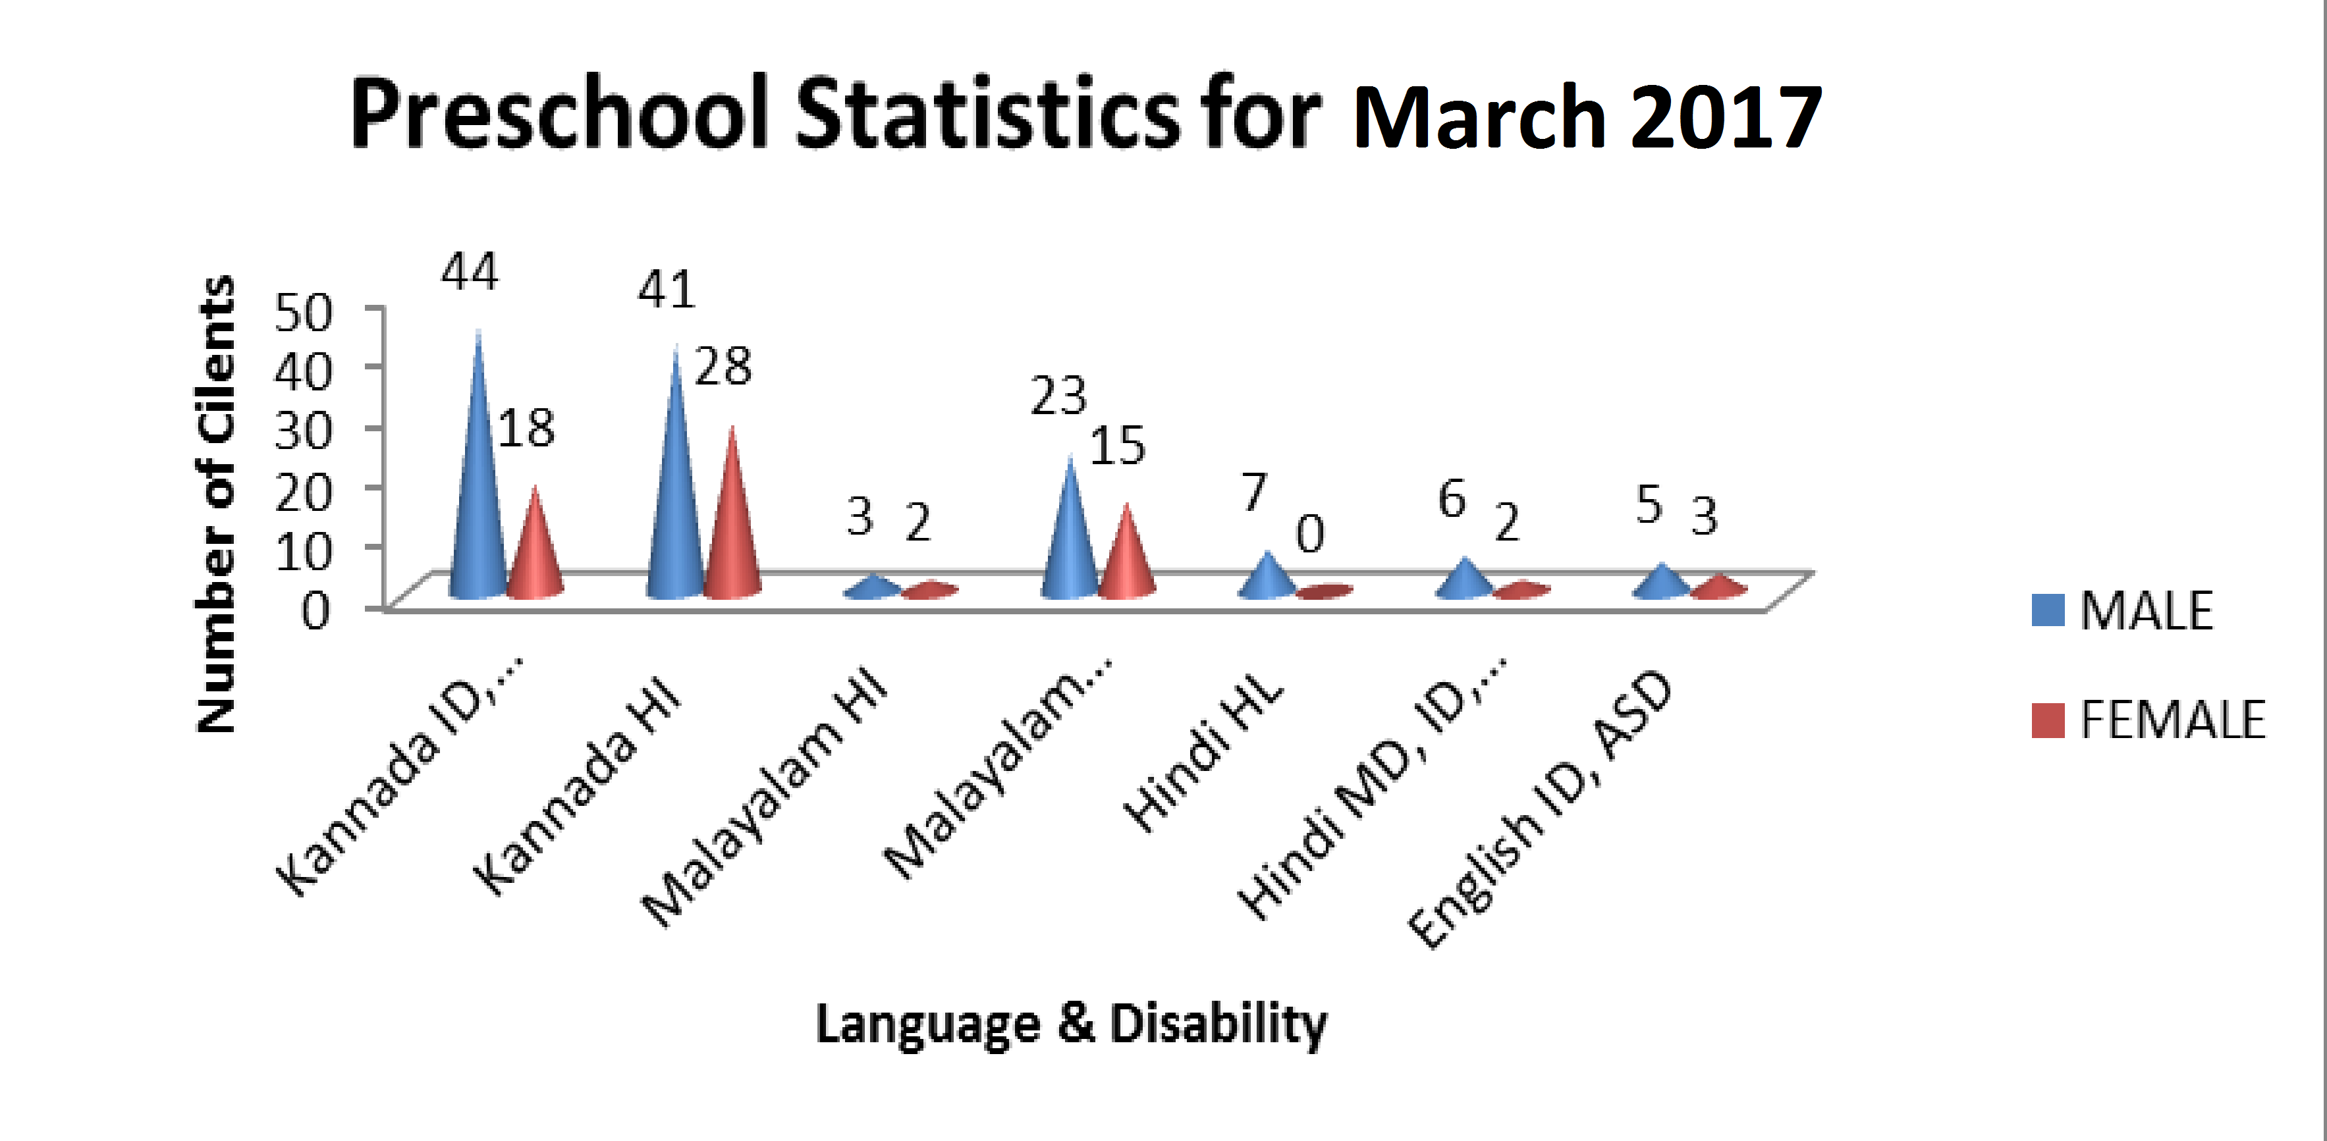

Curricular Support Services – Supportive training to augment education in mainstream school/ other educational programmes – Mr.Harish
 | Language | HL | MR/CP/Down’s/LD | PDD | Total No.of clients | No. Of sessions
 | Kannada | 03 | 06 | 01 | 10 | 44
 | Malayalam | 0 | 01 | - | 01 | 6
 | Hindi | 0 | 0 |  | 0 | 0
 | English | 01 | 08 | - | 09 | 62
 | Telugu | - | 0 | - | 0 | -
 | Tamil | - | - | - | - | -
 | Total |  |  |  | 21 | 118
No. of clients promoted to the next higher level of service:
No. discharged : 01
No. of Old clients :
No. of New clients enrolled: 01
No. discontinued:

Individualised Educational Programme (IEP) – Training in functional academics for out of school individuals– Mr. Harish
 | Language | HL | MR/CP/Down’s/LD | PDD | Total No.of clients | No. Of sessions
 | Kannada | 01 | 04 | 0 | 05 | 23
 | Malayalam | - | 02 |  | 02 | 16
 | Hindi | -- | -- | -- | -- | --
 | English | -- | -- | -- | -- | --
 | Telugu | -- | -- | -- | -- | --
 | Tamil | -- | -- | -- | -- | --
 | Total |  |  |  | 07 | 39

Demonstration Training – Short-term demonstration to caregivers in any of the above –
Mr. Harish
Language | HL | MR/CP/Down’s/LD | PDD | Total No.of clients | No. Of sessions
Kannada | -- | -- | -- | -- | --
Malayalam | -- | 02 | 01 | 03 | 18
Hindi | -- | 01 |  | 01 | 09
English | -- | 01 |  | 01 | 04
Telugu | -- | -- | -- | -- | --
Tamil | -- | -- | -- | -- | --
Total |  |  |  | 05 | 31

Preschool Parent Empowerment Programme – PPEP (Mr. Murshidul Alam):
Buffer programme for children awaiting for preschool admission | Language | HL | ID | CP | ASD | MD | LD | DD | Total No. of clients | No. Of sessions
 | Kannada | 35 | 18 | 00 | 06 | 07 | -- | -- | 66 | 156
 | Malayalam | 02 | 14 | 01 | 08 | 03 | -- | -- | 28 | 100
 | Hindi | 06 | 01 | -- | -- | -- | -- | -- | 07 | 44
 | English | 00 | 00 | -- | -- | 02 | -- | -- | 02 | 19
 | Telugu | 06 | -- | -- | -- | -- | -- | -- | 06 | 22
 | Tamil | 04 | -- | -- | -- | -- | -- | -- | 04 | 22
Total |  |  |  |  |  |  |  |  | 113 | 363
No. of clients promoted to the next higher level of service: 00
No. Of discharged : Nil
No. Of discontinued: 09 (Kannada: HL = 01(Fe), Malayalam: ID= 03 (M=01, Fe=02) MD 01(fe), Hindi: HL= 1 ( Fe), Telugu= 01 (Fe) ), Tamil: 02 (M=01, Fe=01)
No. Of new clients : 25 (Male :18, Fe: 07)

Parent-Infant Programme – PIP (Ms. Leelarani) . (Birth to 2 ½ years)
Early stimulation programme for infants & toddlers with communication disorders | Language | HL | ID | CP | ASD | MD | LD | DD | Total No. of clients | Total No. Of sessions
 | Kannada | 7 | 3 | - | 1 | 5 | - | - | 16 | 74
 | Malayalam | 2 | 11 | - | 1 | 5 | - | - | 19 | 93
 | Hindi | 3 | - | - | - | 1 | - | - | 4 | 37
 | English | - | 1 | - | - | - | - | - | 1 | 1
 | Telugu | - | - | - | - | - | - | - | -
 | Tamil | - | - | - | - | - | - | - | -
 | Total |  |  |  |  |  |  |  | 40 | 205
Specific age range:
No. of Old clients :28
No. of New clients enrolled: 11
No. discharged : NIL
No. discontinued:03
No. of Promoted to next level: 01

Library of Books & Toys – LiBoToy  (Ms. P. V. Ramanakumari & Ms. P. V. Manjula): Services issuing educational toys & books for home-based training | Total number of members enrolled - 136  No. of new members: - 6  Amount – 300/-  Total number of sessions –28
 | Age group | Total number
 | 0-2.6 yrs | 12
 | 2.6-4 yrs | 14
 | 4.0-6yrs | 98
 | 6 yrs and above | 12

Services | Number of Clients | Number of Sessions
Guidance & Counselling | 32 | 29
Co-Curricular Training | 206(includes GEGCS) | 56
U-SAFE | 49 | 09

Supports for Empowering Caregivers
Name of Training Unit | No. of Parent  Beneficiaries | No. of Sessions | Content of Training
Caregiver Computer Training Unit | -- | -- | --
Caregiver Literacy Training Unit | -- | -- | --

Sd/-
Prof. M. Pushpavathi
HOD – Special Education

